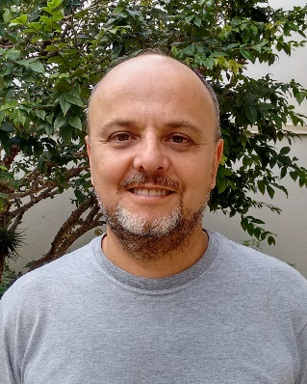
Dr. Augusto de Araújo is a Brazilian Agricultural Engineer with 34 years of research experience on farm machinery design and testing. He obtained the Engineering degree in 1983 at Campinas State University (UNICAMP), Brazil, in 1983, followed by MSc in Mechanical Engineering at the Federal University of Santa Catarina (UFSC), Brazil, in 1993, and a PhD in Electrical Engineering at the University of São Paulo (USP), Brazil, in 2004 in Agricultural Automation agriculture.
Since 1985 until now, he is a researcher in Agricultural Engineering at Instituto Agronomico do Parana (IAPAR), Brazil, focused on research in design and evaluation of agricultural machinery for Conservation Agriculture (No-Tillage) and Small Scale Farm Machinery. He is also involved in applications of information technology in agriculture mainly on fuzzy and neural network modeling.
Since the very beginning of professional life, he devoted big efforts in designing, adapting and evaluating no-till equipment especially for small farmers and he was one of the responsible for small farmers no-till spreading in Southern Brazil. He also worked in diverse African Countries, Guatemala and Cuba with the same ends for United Nations.
He will be lecturer in a CA machinery panel with the speech “SEEDING MACHINERY FOR CONSERVATION AGRICULTURE IN SMALL, MEDIUM AND LARGE FARMS - Present status and Innovations” in August 3rd, 2017 between 12:30AM and 01:30PM.
Seeding in Conservation Agriculture (CA) is the operation whose machinery has experienced most investment in new designs and re-designs aiming to operate efficiently into widely variable residue mulch and untilled soil conditions for manual, draught animal and two- and four-wheel tractor based farming systems.
A selective review of present status of seeding machinery design for CA systems employed in some regions of the world will be presented. It includes technologies in use by farmers or still in a validation but promising stage and reflects experiences and research approaches for CA machinery engineering design adopted to overcome regional problems and challenges.
Besides a brief description of most relevant technical aspects, the selected models of seeding machinery are evaluated considering three important principles of no-tillage, i.e., low soil disturbance level, soil surface cover by residues after seeding and ability to operate with diversified types of seeds to optimize crop rotation including cover crops.
An overview of technological innovations for CA seeding machinery is also included mainly comprising recent commercial components for a better soil-tool-straw interaction and future trends on control systems to improve performance under site-specific seeding management.
The importance of periodic demonstration and field tests of commercial seeding equipment and innovations released in the market as well a comprehensive transfer of technical information for farmers and technical advisers will be discussed as a strategy to improve farmer ability to select the best model for his condition and to accelerate design improvements from manufacturer side.

